**Paper 1 Question 1 tectonic hazards**

**Paper 1 Question 1 weather hazards**

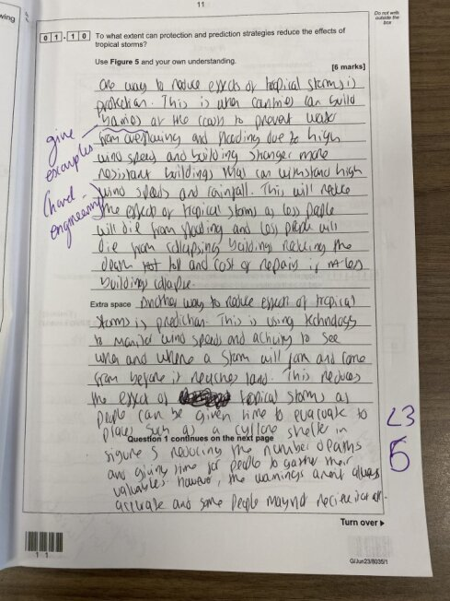

**Paper 1 Question 1 Climate change**

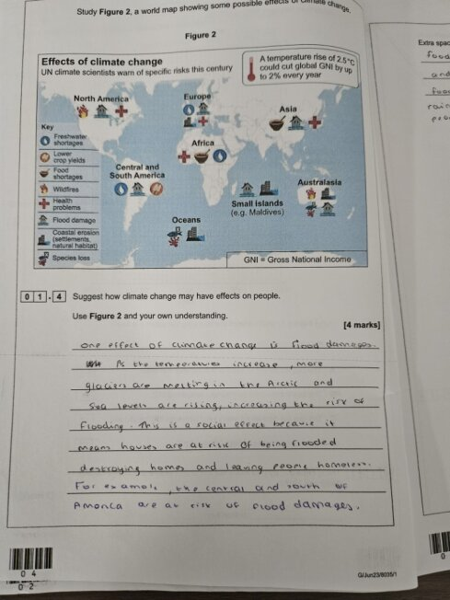

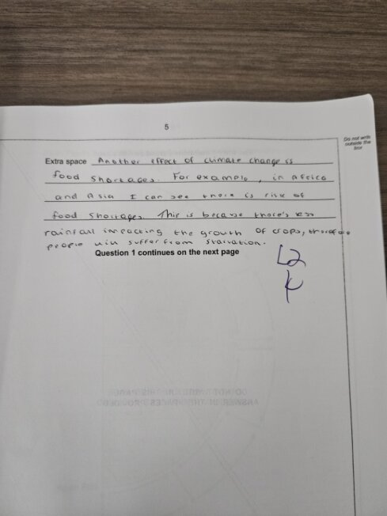

**Paper 1 Question 2 Living world**

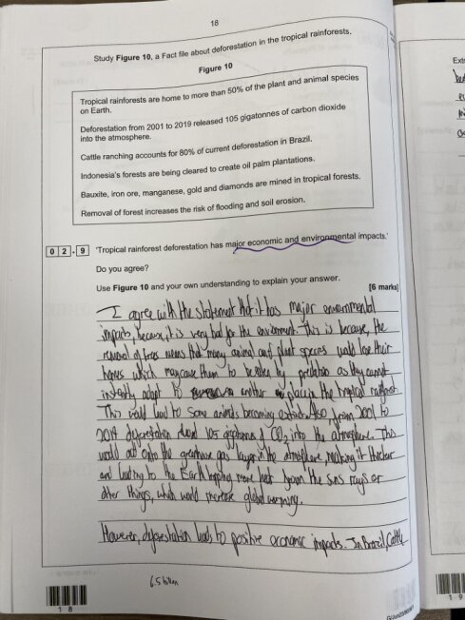

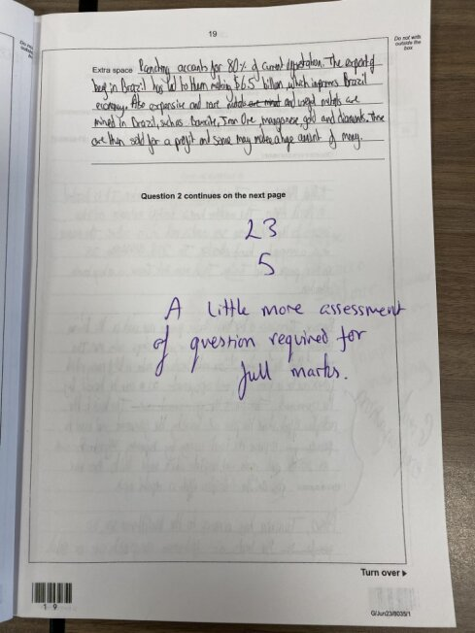

**Paper 1 Question 4 - Rivers**

