**Paper 2 model answers**

**Question 1 – urban issues and challenges**

**UK city - Liverpool**

**UK city - Liverpool**

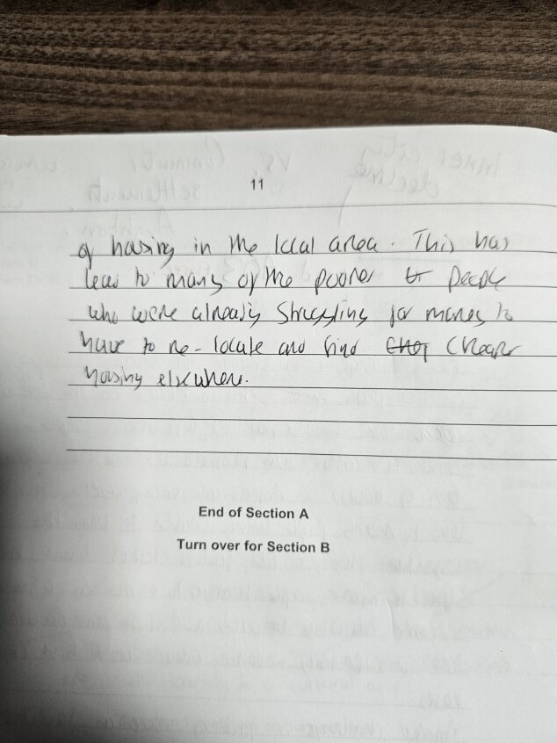

**Question 2 – Changing economic world**

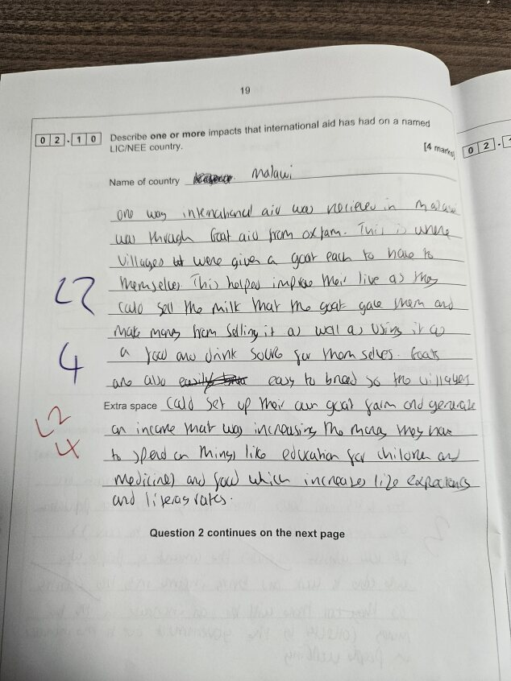

**Nigeria – TNC (Shell)**